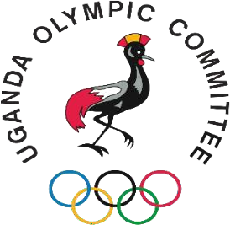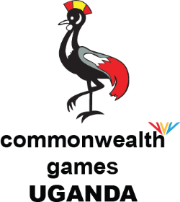



INSIDE
King’s Baton Relay Commissions’ Induction Game Connect Media Clinic 10th Olympic Values Contest SAC and ASMC
GAPS Africa Para Sport camp
1st ANOCA School Games Continue Federation’s Corner

Commissions’ Induction
The Uganda Olympic Committee (UOC) held a successful induction ceremony for its newly appointed commissions on the 5th July 2025 at the UOC Offices. The event brought together UOC Executive Board members, commission chairpersons, and members to set priorities for the term and align with the UOC's constitution and strategic plan. Key topics discussed included funding opportunities, financial procedures, and the importance of leadership, providing a solid foundation for the commissions to drive the UOC's objectives forward.

July 2025: Issue 7

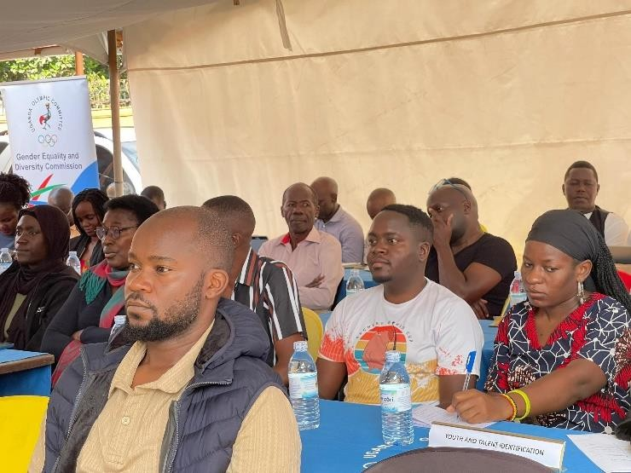
Commission heads and members at the Induction.

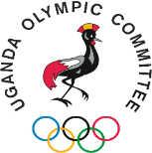
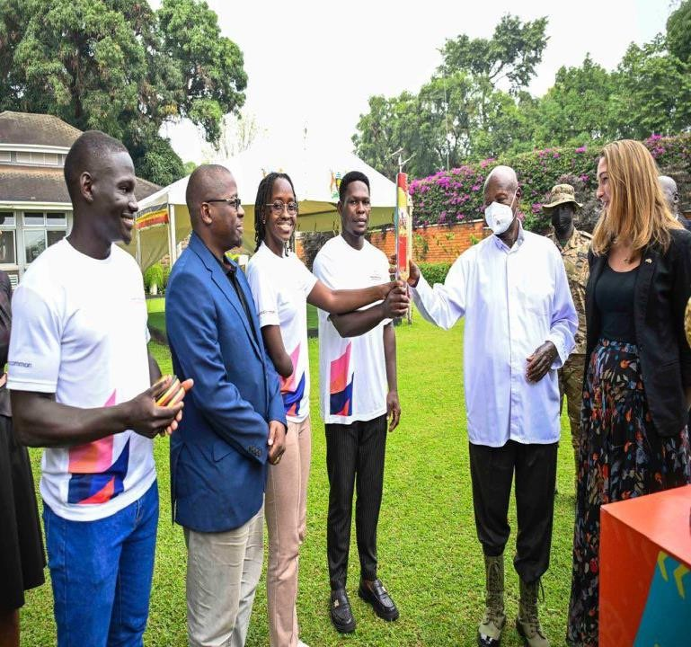
King’s Baton Relay
Commonwealth Games Uganda (CGU) ignited a spark of unity and environmental awareness with the King's Baton Relay, a thrilling 5-day extravaganza that captivated the nation from 3rd July to 8th July 2025. With a star-studded press conference launch featuring H.E. Tiffany Kirlew the Deputy Ambassador, British High Commission to Uganda, Ms. Sarah CHELANGAT representing NCS, IOC Member Mr. William Fredrick BLICK, The V.P UOC|CGU Mr. Moses B. MWASE and Federation heads in attendance. On 5th, the Baton was then taken to the rugged beauty of Kapchorwa, Teryet High Altitude Training Centre then Sebei College Tegeres in company of the triple gold medalist, Victor KIPLANGAT. The thrill at the swimming championships on the 6th, a prestigious State House reception on the 7th, and a community-led clean-up of Lake Victoria's shores on the 8th. As the Baton made its final bow at the Rugby Africa Cup Championship, Uganda's passion for sports and sustainability shone bright, leaving an indelible mark on this Commonwealth Games precursor event.

Baton being presented to the president H.E Yoweri Kaguta Museveni at the State House in Nakasero

Game Connect Media Clinic
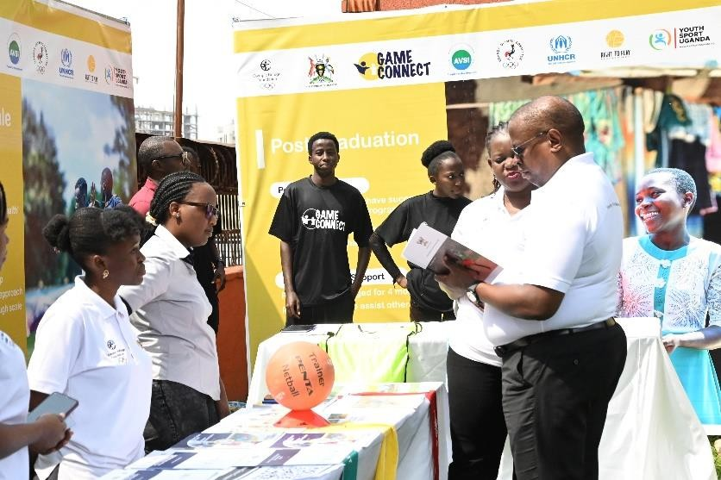
Dr. Donald Rukare at the Game Connect media clinic
The Uganda Olympic Committee (UOC) together with the Game Connect Project successfully held the Game Connect Media Clinic at its offices on 11 July 2025. Over 15 journalists attended the training, focusing on the role of sports in improving mental health, particularly through the Sport for Protection programme. This initiative, supported by AVSI, aims to create well-being communities globally by engaging youths in sports and life skills development. The Project, which targets youths between 10 and 24 years of age, has successfully engaged 19,365 youths participated in bi-weekly sessions, with a notable participation of 11,271 refugees and 8,094 host community members. Dr. Donald Rukare, a key figure in the project, highlighted its impact on overcoming anxiety and depression, especially in refugee settlements like Kyangwali.

GAPS Africa Para Sport Camp
The GAPS Africa Para Sport camp was held in Stellenbosch, South Africa, from 18 July to 27 July 2025, with Rebecca Zawedde, a para- powerlifting athlete, and Regina Nakibuule,

Lead Coach, representing Uganda. The camp, part of Commonwealth Sport's GAPS program, aimed to grow Para Sport across Africa and increase African Para representation at future Commonwealth Games, providing advanced training, scientific assessments, coach development, nutrition, and anti-doping education to develop athletes and coaches in Para Athletics and Para Powerlifting.

SAC and ASMC Program
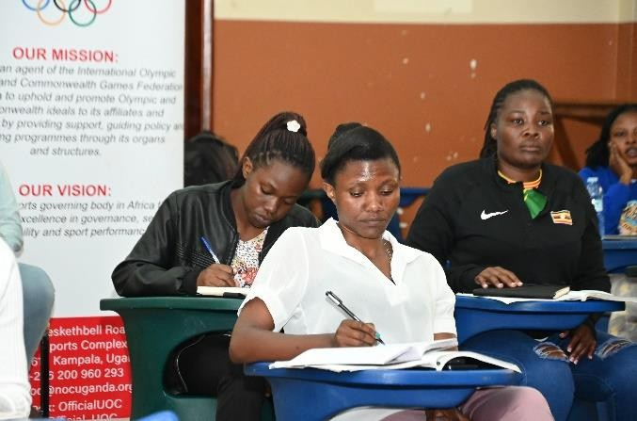
Participants in the Women’s ASMC Class
The Uganda Olympic Committee (UOC), through its Capacity Building department led by Mr. George Wagoogo, successfully conducted the Advanced Sport Management Course (ASMC) in July 2025. The course was held in two segments: the General Class took place on July 5th, 6th, 26th, and 27th, while the Women Class was held on July 19th and 20th. Participants gained valuable insights into key areas of sports management, including marketing and event organization. These skills will empower them to drive sports development and management in Uganda, contributing to the growth of the sports sector. Additionally, the Capacity Building Department is currently conducting a Sports Administrators Course (SAC) in Mityana from 31 July to 2 August, further demonstrating its commitment to building capacity in sports administration.

1st ANOCA School Games Continue
The Uganda Olympic Committee (UOC) and National Council of Sports (NCS) proudly announced Uganda's participation in the inaugural African School Games (ANOCA School Games) that kicked off on 26 July 2025 and will end on 5 August 2025, in the Algerian cities of Annaba, Constantine, Setif, and Skikda. An 88-member delegation led by CDM Lydia Gloria DHAMUZUNGU to Algeria, comprising athletes and officials, was officially flagged off on 21 July 2025, at the Copper Chimney Restaurant in Lugogo by Dr. Bernard Patrick OGWEL, General Secretary of the National Council of Sports. Four esteemed schools are currently representing Uganda: Buddo SS, Ngora High School, Seroma Christian High School, and Gayaza High School. Additionally, national select teams for swimming and athletics are competing as well, showcasing Uganda's diverse athletic talents in sports like football, lawn tennis, table tennis, 3x3 basketball, badminton, beach volleyball, swimming, and athletics. The Ugandan contingent is gallantly representing the country, striving for excellence and promoting the values of sportsmanship and fair play. We wish them a successful and memorable experience in Algeria.
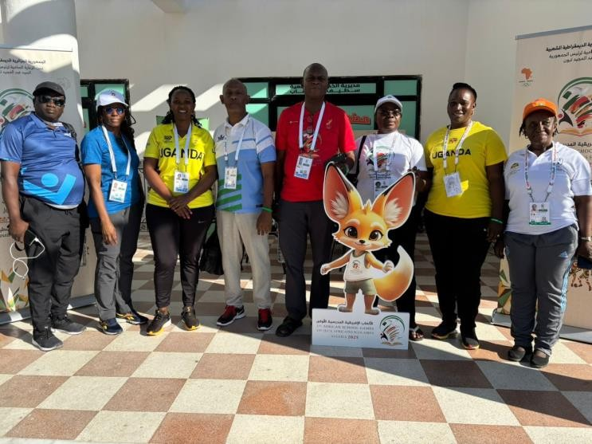
Dignitaries from Uganda and other nations pose for a photo.

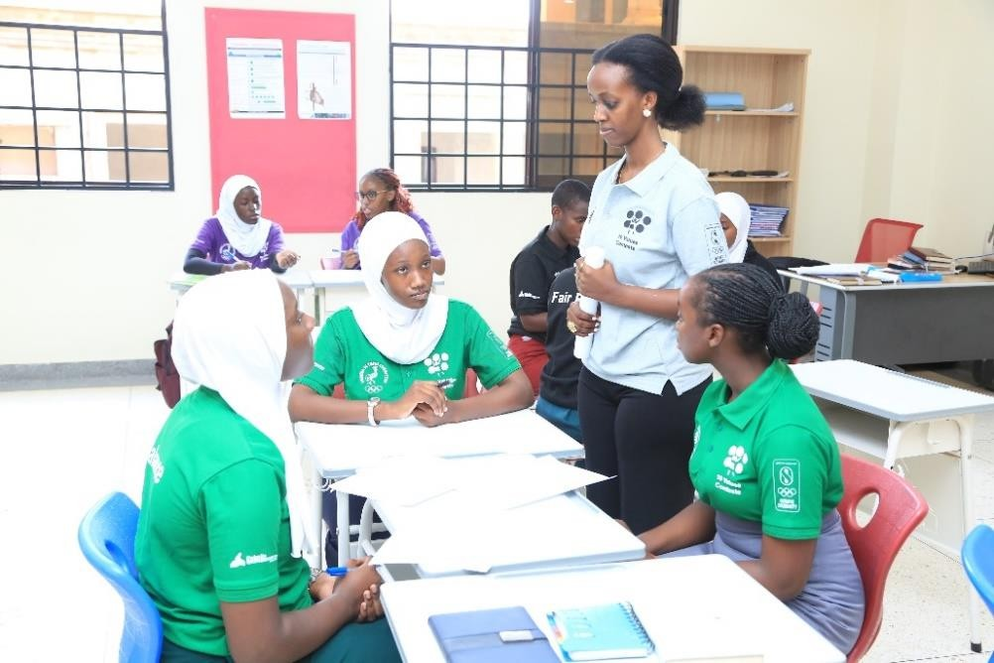
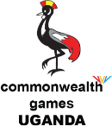
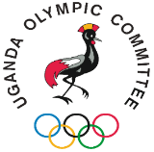
10th edition of the Olympic Values Contests
The Uganda Olympic Committee (UOC) through its Culture and Education commission marked a decade of the Olympic Values Contest with a thrilling celebration at Kabojja International School on
26 July 2025, where over 300 students from 30 schools participated in the 10th edition of this annual event, which started in 2015. Initially announced through a
press conference on 23 July. The students were grouped into teams representing core Olympic values: Excellence, Peace, Humanity, Friendship, Solidarity, Respect, Fair Play, Balance, and Joy of Effort, with Team Solidarity comprising the event's organizers and Team Equity representing judges and officials from Debate Society Uganda (DSU). The students competed in brain-powered activities that showcased their intellect, teamwork, and commitment to holistic education. Team Friendship emerged as the overall winner, and exceptional students were recognized, with two debaters Blessing Tugume and Mwesigire Karyn, who earned the honor of representing Uganda at the 65th Session of the International Olympic Academy Youth Ambassadors Program in Athens, Greece next year.

Participants in a discussion at the Olympic Vales

Dr. Donald Rukare Joins World Aquatics Bureau
Dr. Donald Rukare, the esteemed President of the Uganda Olympic Committee (UOC), Commonwealth Games Federation and a renowned sports leader, has been elected to the World Aquatics Bureau as a Continental Representative for Africa. This election, which took place on 29 July 2025, marks a significant milestone for African aquatic sports and underscores Dr. Rukare's exceptional leadership and dedication to the development of aquatics globally. Dr. Rukare's appointment to the World Aquatics Bureau is a testament to his vision, expertise, and tireless efforts to promote aquatic sports in Africa and beyond. His presence in the Bureau will undoubtedly drive positive change, foster growth, and promote aquatic sports development across the continent, inspiring a new generation of aquatic athletes and officials. This achievement not only elevates Africa Aquatics on the global stage but also cements Dr. Rukare's position as a trailblazer in African sports leadership. We extend our warmest congratulations to Dr. Rukare on this well-deserved recognition and look forward to the impact his leadership will have on the future of
aquatic sports in Africa and worldwide.

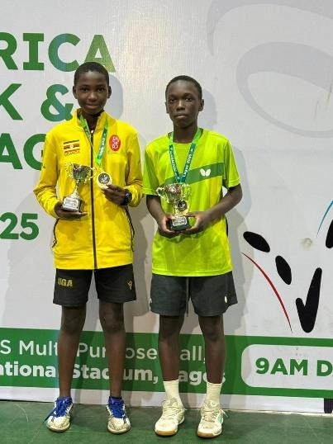
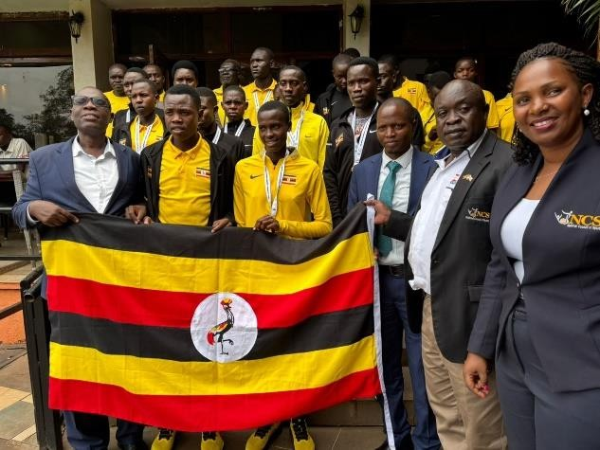

Table Tennis

Patience Anyango and Joseph Sebatindira pose for a photo with their anklets
Uganda Table Tennis Association's team in Nigeria for several tournaments has already won Gold in the hopes week and challenge with Patience Anyango retaining her title as Joseph Sebatindira edged all under 12 boys. Anyango added another Gold in a girls under 15 team's performance alongside Jemimah Nakawala and Patra Nasirumbi that yielded the nation's first ever continental Gold. The team of seven players that includes Ibrahim Mutesasira, Shariff Nsereko and Judith Parvin Nangonzi and under coaches Alvin Katumba and Tendo Balyewunya continues its search for medals in both under 15 and 19 categories of the ITTF Africa Youth championship that will be followed by the Africa Youth Cup that climaxes on 5 August 2025.
Federation’s Corner
Athletics

Dignitaries and Athletes pose for a photo.
Team Uganda delivered a stellar performance at the 4th edition of the CAA African U18/U20 Athletics Championships, held in Abeokuta, Nigeria, from July 16 to 20, 2025. The Ugandan athletes clinched a total of nine medals, including four gold, one silver, and four bronze, showcasing the country's rising dominance in youth athletics. Notable performances included Samuel Simba Cherop's gold in the U20 men's category, Bentalin Chemutai's gold in the 3000m race, and a sweep of top honors in the U20 women's 5000m event, with Charity Cherop and Nancy Chepkwurui claiming gold in their respective heats. Officials from the Uganda Athletics Federation (UAF) praised the performance as a testament to Uganda's growing strength in the sport, highlighting a bright future for the country's youth athletes.

Volleyball
The Uganda Volleyball fraternity celebrated the life and times of 'Old Coach' Neko MUDUSE who passed away in 2021. Old Coach was renowned for his impact at Nemo Stars, a club he played a pivotal role in forming.
A memorial service at St Luke Church and a memorial tournament at Uganda Christian University (UCU) Mukono were part of the events organized.

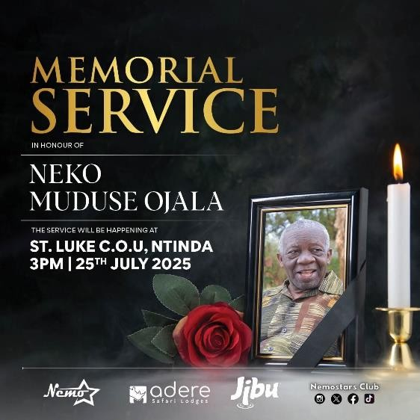

Uganda Olympic Committee | Commonwealth Games Uganda
Plot 2-10 Heskethbell Road, Lugogo sports complex
Facebook:
facebook.com/ugandaolympic.com LinkedIn: Uganda Olympic Committee Instagram: Official UOC
YouTube: @UgandaOlympicCommittee X: official UOC
Email: uoc@nocuganda.org
Tel: +256 200 960293
Website: www.nocuganda.org
© 2025 – Uganda Olympic Committee

INSIDE
1st ANOCA School Games
Advanced Sport Management Course
Athlete 3C5+ Career Development Workshop Game Connect Annual Gala

August 2025: Issue 8

1st ANOCA School Games
The first-ever ANOCA (Association of National Olympic Committees of Africa) School Games, held in Algeria from 26 July to 5 August 2025, concluded successfully with Uganda finishing 13th out of 50 participating nations and returning home with five medals—one gold, one silver, and three bronze. The medalists included Cheriton Baskaline, who won gold in the 1500m, Karen Chelimo with silver in the 3000m, and Risper Chekwemboi who secured bronze in the 1500m, while Buddo SS triumphed with bronze in boys’ football and Seroma Christian School earned bronze in the girls’ 3x3 basketball. Chief de Mission Mrs. Lydia Gloria Dhamuzungu commended the performances of the young athletes, noting that despite limited preparation time and a relatively small delegation, they showcased great potential on their international debut.

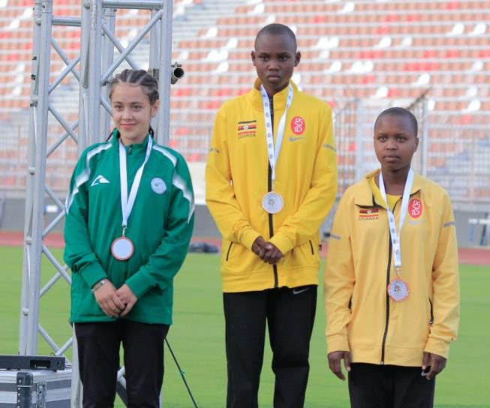
Cheriton and Karen at the Podium with Gold and Silver respectively.

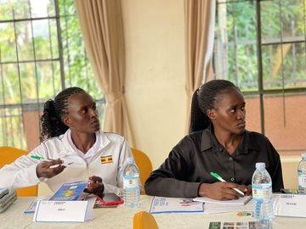

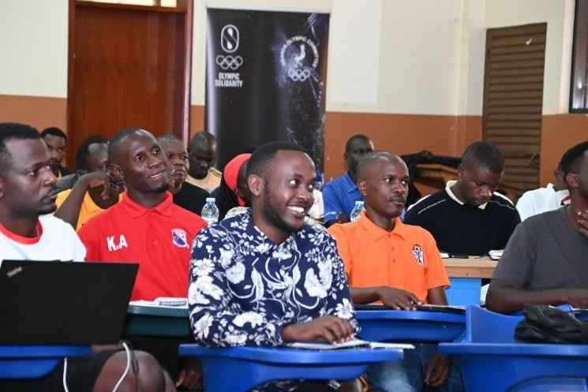
The Uganda Olympic Committee (UOC), through its Capacity Building department led by Mr. George Wagoogo, successfully conducted the last Advanced Sport Management Course (ASMC) for module 6 about Event management on 16 August 2025. The participants were appreciative to the Uganda Olympic Committee and about the impact of the program onto their lives. These skills will empower these administrators, coaches and Technical Personnel to drive sports development and management in Uganda, contributing to the growth of the sports sector.
Advanced Sports Management
Course
Participants in the ASMC General Class

Athlete365+ career development workshop
The Uganda Olympic Committee organized the Athlete365 Career+ workshop on 22 August to 23 August 2025, at Nob View Hotel in Ntinda. The two- day program, supported by Olympic Solidarity and moderated by IOC Instructor and Olympian Mr. Ganzi Semu Mugula OLY, equipped elite athletes with tools for career transition, education, and personal development as part of the IOC’s global Athlete365 initiative. UOC President Dr. Donald Rukare urged participants to take the program seriously, emphasizing the importance of preparing for life beyond sport.
Participants at the Athlete3c5+ workshop

Game Connect Annual Gala
The Game Connect Project held its Annual Gala from 28 August 2025 to 29 August 2025, at Kyangwali Refugee Settlement in Kikuube District hosted at Kyangwali Secondary School. The event brought together 114 refugee youth from the districts of Kikuube, Adjumani, Kamwenge, and Kampala to participate in football, netball, and volleyball under the theme #GameOnForChange. Adjumani Settlement emerged as the overall winner of the competitions. The Gala was graced by the IOC/ORF team, and the Uganda Olympic Committee was represented by its 1st Vice President, Mr. Godwin Kayangwe.

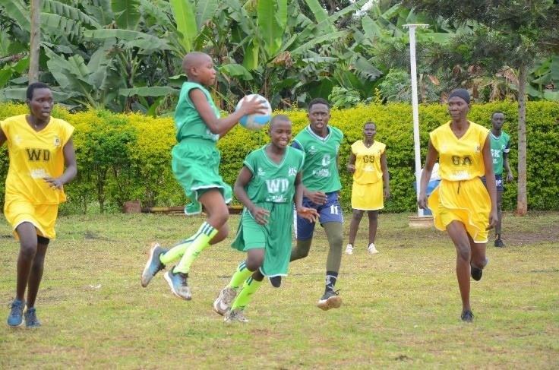
Participants during a netball match

Uganda Olympic Committee | Commonwealth Games Uganda Plot 2-10 Heskethbell Road, Lugogo sports complex
Facebook: facebook.com/ugandaolympic.com LinkedIn: Uganda Olympic Committee Instagram: Official UOC
YouTube: @UgandaOlympicCommittee X: official UOC
Email: uoc@nocuganda.org
Tel: +256 200 960293
Website: www.nocuganda.org
© 2025 – Uganda Olympic Committee

